DBMS PROJECT
University of Veterinary and Animal Sciences
Muhammad Asif
2024-csre-008
BS Computer Science (Evening)
Semester: 2nd
Database Management System

Submitted to: Mr. Aness Ahmad
Date: 17/06/2025
  - Project that made by implementing all basics queries of MySQL language.

Contents
Queries list that implemented in this Project: 3
◼ Create table table_name 3
-- Create the Users table 3
--Create the Categories table 4
--Create the SubCategories table 4
--Create the Products table 4
--Create the Orders table 5
--Create the Order_Items table 5
◼ DROP table table_name 6
--Deleting the Order_Items table 6
▪ Insert into table_name 6
-- Insert in Users table 6
-- Insert in Categories table 7
-- Insert in SubCategories table 7
-- Insert in Products table 8
-- Insert in Order table 8
-- Insert in Order_Item table 9
◼ Retrieve data from table 9
■ Retrieve Specific data 9
■ Using SELECT DISTINCT 10
■ COUNT Clause 10
■ DISTINCT Count Clause 10
■ LIMIT Clause 11
■ Where Clause 11
■ Using IN operator with WHERE 11
■ Using Between Operator 12
■ ORDER BY Clause 12
■ Using HAVING & GROUP BY clause 13
■ DELETE Clause 13
■ UPDATE Clause 13
■ MIN Clause 14
■ MAX Clause 14
■ Nested Queries 15
■ INNER JOIN 15
■ LEFT JOIN 15

Queries list that implemented in this Project:

◼ Create table table_name
Use case:
This Query is used to create a table in a database. In this we define all attributes of this table, its data type and limit etc. The primary key a foreign key all also defined within in this. We also apply such limits that this attribute value does remain empty.

-- Create the Users table
CREATE TABLE Users (
user_id INT PRIMARY KEY,
name VARCHAR(255) NOT NULL,
email VARCHAR(255) NOT NULL UNIQUE,
password_hash VARCHAR(255) NOT NULL
);
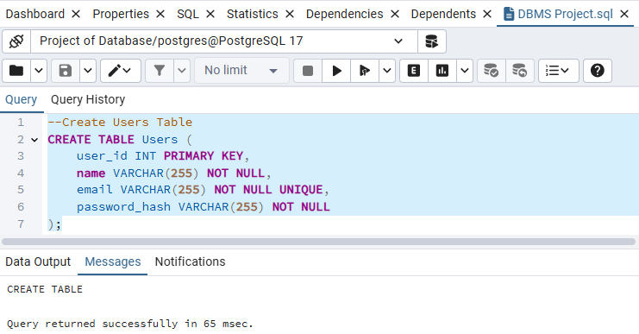

--Create the Categories table
CREATE TABLE Categories (
category_id INT PRIMARY KEY,
category_name VARCHAR(255) NOT NULL UNIQUE
);
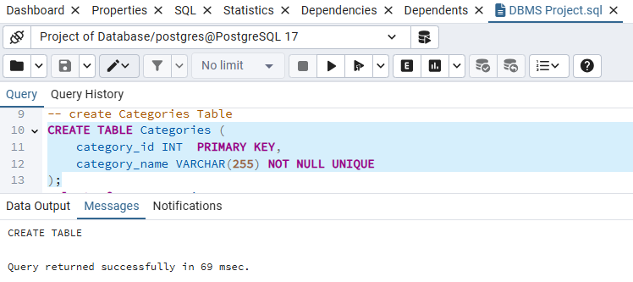

--Create the SubCategories table
CREATE TABLE SubCategories (
subcategory_id INT PRIMARY KEY,
subcategory_name VARCHAR(255) NOT NULL,
category_id INT NOT NULL,
FOREIGN KEY (category_id) REFERENCES Categories(category_id) ON DELETE CASCADE
);
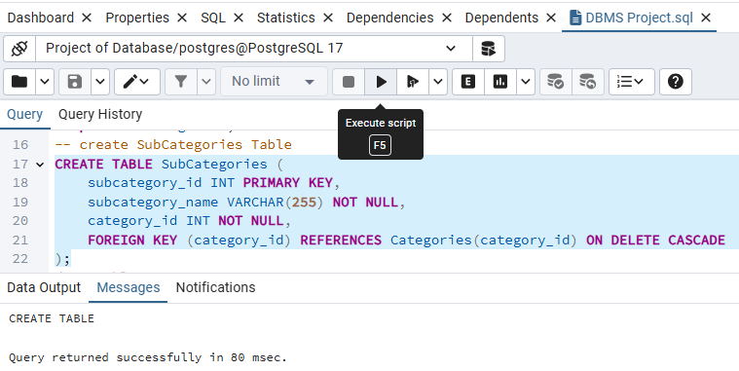

--Create the Products table
CREATE TABLE Products (
product_id INT PRIMARY KEY,
product_name VARCHAR(255) NOT NULL,
description TEXT,
price DECIMAL(10, 2) NOT NULL,
stock_quantity INT NOT NULL DEFAULT 0,
subcategory_id INT NOT NULL,
FOREIGN KEY (subcategory_id) REFERENCES SubCategories(subcategory_id) ON DELETE RESTRICT
);
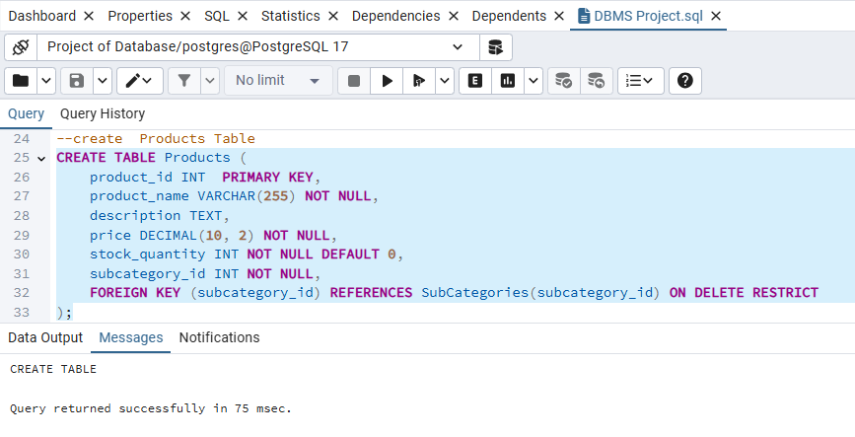

--Create the Orders table
CREATE TABLE Orders (
order_id INT PRIMARY KEY,
user_id INT NOT NULL,
order_date int,
total_amount DECIMAL(10, 2) NOT NULL,
payment_method VARCHAR(50) NOT NULL,
status varchar(40),
-- status ENUM('Pending', 'Processing', 'Shipped', 'Delivered', 'Cancelled') NOT NULL DEFAULT 'Pending',
FOREIGN KEY (user_id) REFERENCES Users(user_id) ON DELETE RESTRICT
);
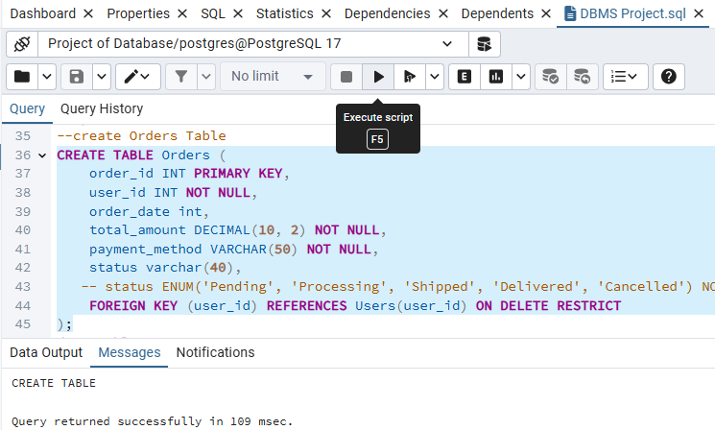

--Create the Order_Items table
CREATE TABLE Order_Items (
order_item_id INT PRIMARY KEY,
order_id INT NOT NULL,
product_id INT NOT NULL,
quantity INT NOT NULL,
price_at_purchase DECIMAL (10, 2) NOT NULL,
FOREIGN KEY (order_id) REFERENCES Orders(order_id) ON DELETE CASCADE,
FOREIGN KEY (product_id) REFERENCES Products(product_id) ON DELETE RESTRICT
);

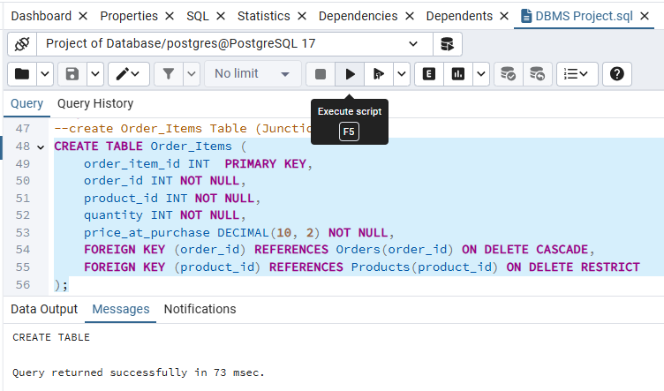

◼ DROP table table_name
We use DROP Clause to delete the whole table, including its table or rows also. No data will survive after this. We need to create the table again and again and insert data into this table.

Syntax:

--Deleting the Order_Items table
drop table Order_Items;
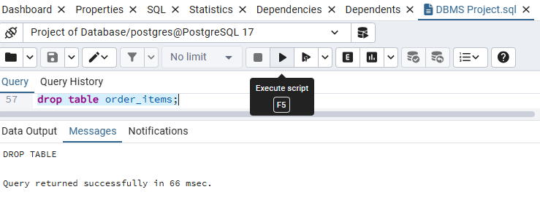

▪ Insert into table_name
Use case:
This Query is used to insert data into a particular table. This data is inserted into a table in that sequence in which the defined. VARCHAR data is written in single quotes, and numeric data is written without single quotes.
Syntax:

-- Insert in Users table
INSERT INTO Users (user_id,name, email, password_hash) VALUES
(1,'Admin User', 'admin@example.com', 'admin_hash_123'),
(2,'Alice Smith', 'alice@example.com', 'alice_hash_456'),
(3,'Bob Johnson', 'bob@example.com', 'bob_hash_789');

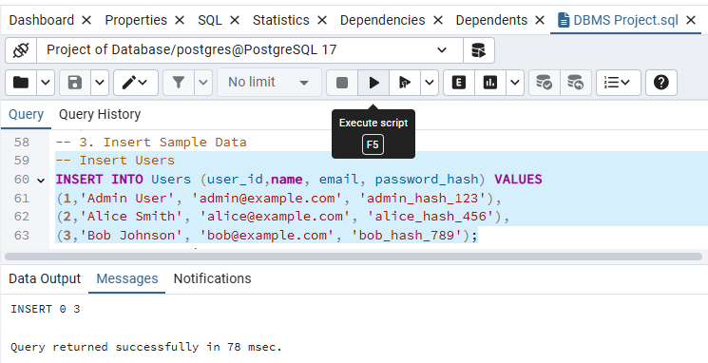

-- Insert in Categories table
-- Insert Categories
INSERT INTO Categories (category_id,category_name) VALUES
(1,'Electronics'),
(2,'Fashion'),
(3,'Home Appliances');

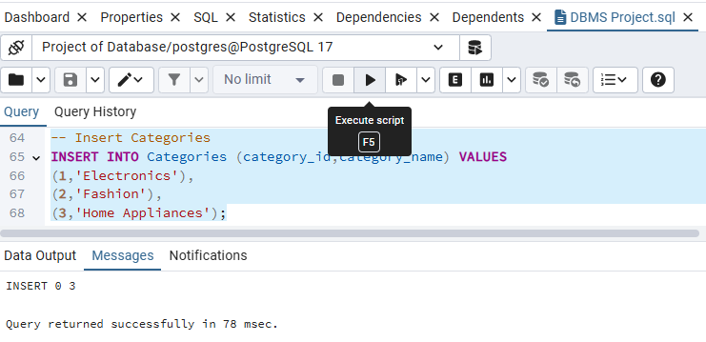

-- Insert in SubCategories table
-- Insert SubCategories
INSERT INTO SubCategories (subcategory_id, subcategory_name, category_id) VALUES
(1,'Mobile Phones', (SELECT category_id FROM Categories WHERE category_name = 'Electronics')),
(2,'Laptops', (SELECT category_id FROM Categories WHERE category_name = 'Electronics')),
(3,'Men''s Clothing', (SELECT category_id FROM Categories WHERE category_name = 'Fashion')),
(4,'Women''s Clothing', (SELECT category_id FROM Categories WHERE category_name = 'Fashion')),
(5,'Kitchen Appliances', (SELECT category_id FROM Categories WHERE category_name = 'Home Appliances'));

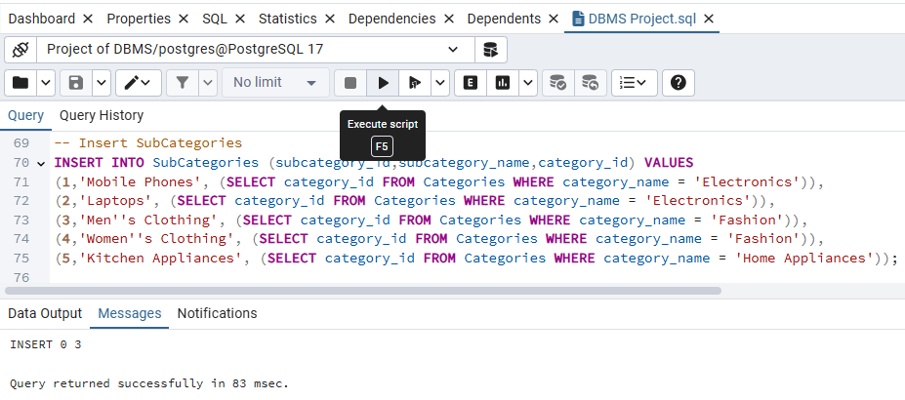

-- Insert in Products table
INSERT INTO Products (product_id,product_name, description, price, stock_quantity, subcategory_id) VALUES
(1,'iPhone 14', 'Apple iPhone with A15 Bionic chip', 999.99, 10, (SELECT subcategory_id FROM SubCategories WHERE subcategory_name = 'Mobile Phones')),
(2,'Samsung Galaxy S23', 'Flagship Android phone by Samsung', 899.99, 15, (SELECT subcategory_id FROM SubCategories WHERE subcategory_name = 'Mobile Phones')),
(3,'MacBook Pro 16', 'Powerful laptop for professionals', 1999.99, 5, (SELECT subcategory_id FROM SubCategories WHERE subcategory_name = 'Laptops')),
(4,'Dell XPS 13', 'Compact and elegant Windows laptop', 1299.99, 8, (SELECT subcategory_id FROM SubCategories WHERE subcategory_name = 'Laptops')),
(5,'Men''s Classic T-Shirt', '100% cotton casual t-shirt', 29.99, 50, (SELECT subcategory_id FROM SubCategories WHERE subcategory_name = 'Men''s Clothing')),
(6,'Women''s Summer Dress', 'Lightweight and stylish summer dress', 49.99, 30, (SELECT subcategory_id FROM SubCategories WHERE subcategory_name = 'Women''s Clothing')),
(7,'Coffee Maker', 'Automatic drip coffee maker', 75.00, 20, (SELECT subcategory_id FROM SubCategories WHERE subcategory_name = 'Kitchen Appliances'));

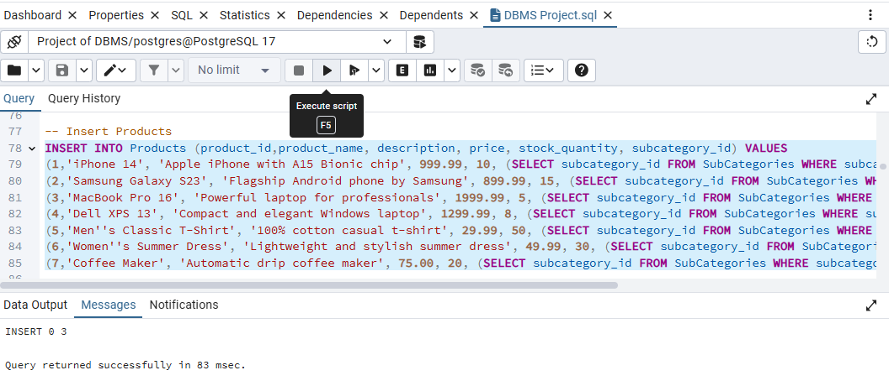

-- Insert in Order table
-- Insert Orders
INSERT INTO Orders (user_id,order_id, total_amount, payment_method, status) VALUES
((SELECT user_id FROM Users WHERE email = 'alice@example.com'),1, 1999.99, 'Credit Card', 'Delivered'),
((SELECT user_id FROM Users WHERE email = 'bob@example.com'), 2,999.99, 'Debit Card', 'Processing'),
((SELECT user_id FROM Users WHERE email = 'alice@example.com'),3, 129.97, 'Jazz_Cash', 'Pending');

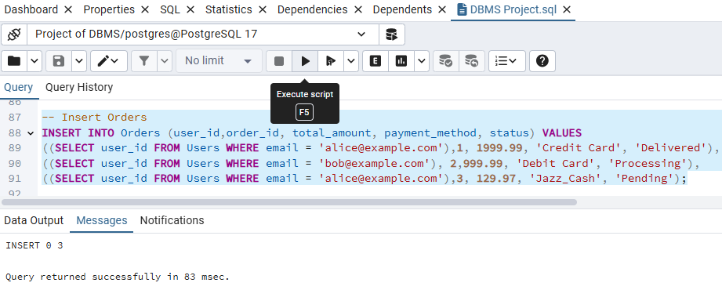

-- Insert in Order_Item table
-- Insert Order_Items
INSERT INTO Order_Items (order_id, product_id,order_item_id, quantity, price_at_purchase) VALUES
((SELECT order_id FROM Orders WHERE user_id = (SELECT user_id FROM Users WHERE email = 'alice@example.com') AND total_amount = 1999.99),
(SELECT product_id FROM Products WHERE product_name = 'MacBook Pro 16'),1, 1, 1999.99),
((SELECT order_id FROM Orders WHERE user_id = (SELECT user_id FROM Users WHERE email = 'bob@example.com')),
(SELECT product_id FROM Products WHERE product_name = 'iPhone 14'),2, 1, 999.99),
((SELECT order_id FROM Orders WHERE user_id = (SELECT user_id FROM Users WHERE email = 'alice@example.com') AND total_amount = 129.97),
(SELECT product_id FROM Products WHERE product_name = 'Men''s Classic T-Shirt'),3, 2, 29.99),
((SELECT order_id FROM Orders WHERE user_id = (SELECT user_id FROM Users WHERE email = 'alice@example.com') AND total_amount = 129.97),
(SELECT product_id FROM Products WHERE product_name = 'Women''s Summer Dress'),4, 1, 49.99);

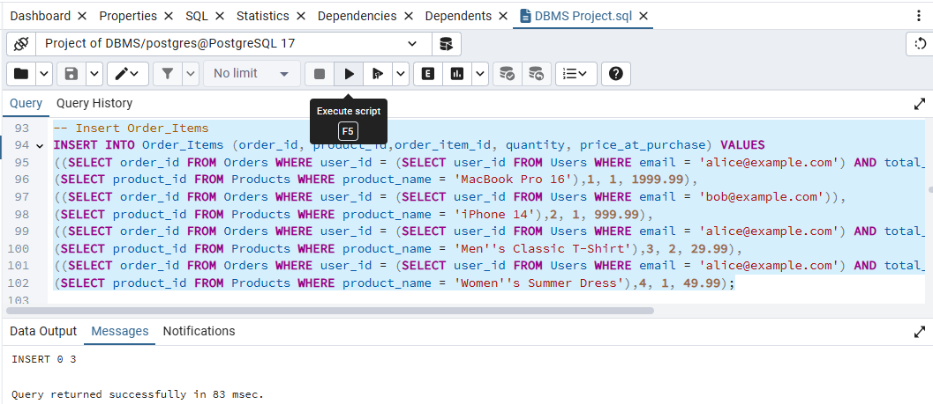

◼ Retrieve data from table
This Query is used to retrieve / See data from a Particular table. We also retrieve a particular column or row by applying condition.

-- SELECT * FROM Clause:
- - Retrieve all columns and all rows from a table
SELECT * FROM Users;

- Retrieve Specific data

select order_id, total_amount, payment_method, status from orders;
SELECT name, email
FROM Users
WHERE NOT email = 'alice@example.com';

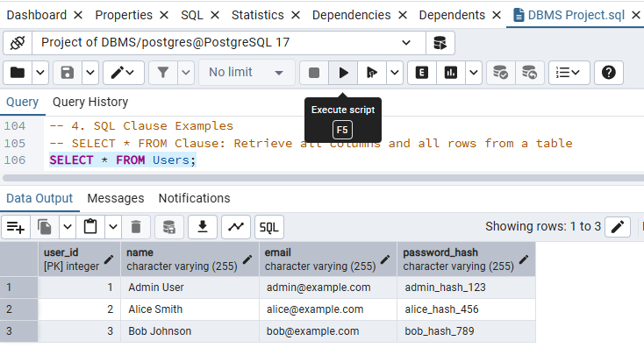

- Using SELECT DISTINCT

SELECT DISTINCT subcategory_id,subcategory_name, category_id FROM subcategories;

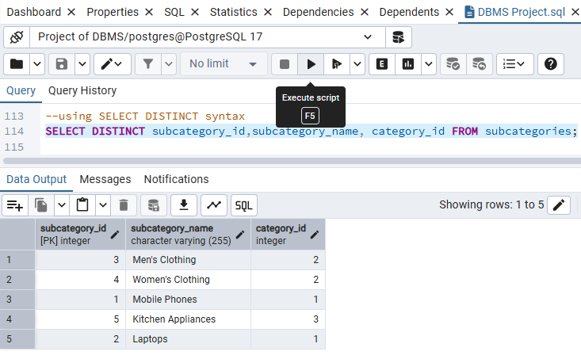

- COUNT Clause
This COUNT clause is used to retrieve total numbers of inserted data count such as how many students’ data is inserted into database etc.

-- COUNT Clause:
SELECT COUNT(*) FROM Users;

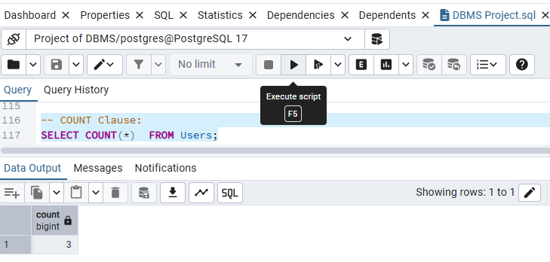
- DISTINCT Count Clause

SELECT COUNT(DISTINCT product_id )FROM products;

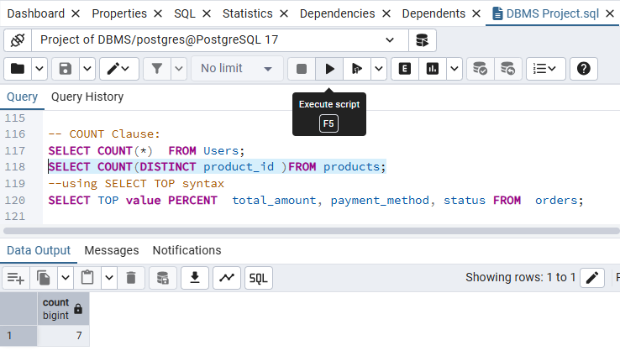

- LIMIT Clause
Limit query is used to limit specific data such as we use it when we want to retrieve only first two rows etc.

SELECT* FROM orders LIMIT 2;

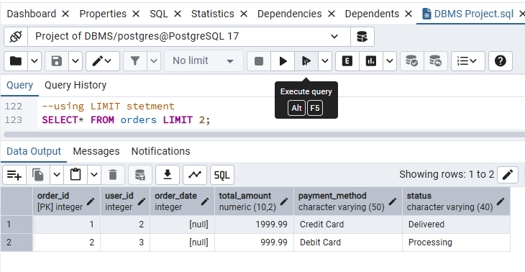

- Where Clause
This clause is used to retrieve specifics data from a table or row etc. This clause is used when specific data needed to be retrieved such as in some conditions we need to retrieve only the name of student, or we only want to display the roll no of student. In such cases we use WHERE clause to target specific data from table.

-- Using SQL WHERE Clause:
SELECT product_name, price FROM Products WHERE price > 500;

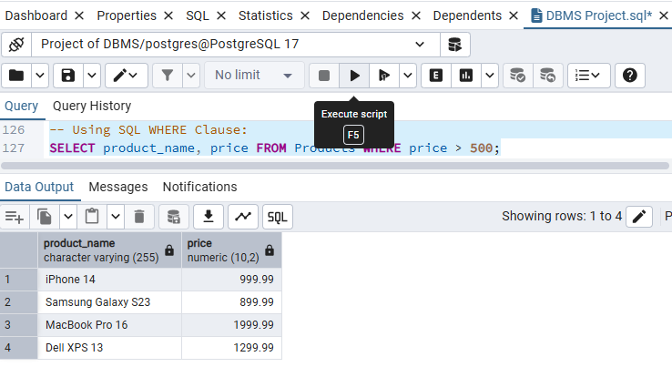
- Using IN operator with WHERE

--Using IN operator with WHERE
select*from orders
WHERE order_id IN (1,2,3);

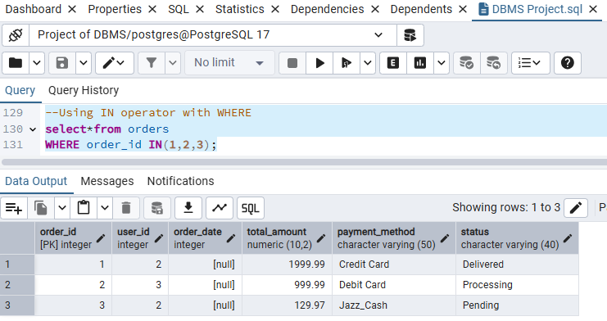

- Using Between Operator

This Operator is used to retrieve data in a specific range such as sometimes we need to retrieve data in between id from 1 – 3 etc.

--using BETWEEN operator
select*from users
WHERE user_id BETWEEN 1 AND 3;

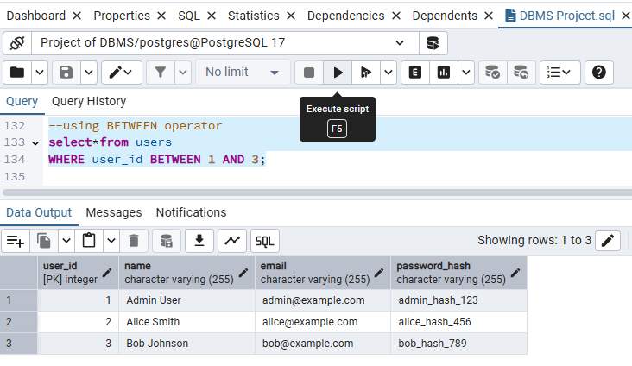

- ORDER BY Clause
This clause is used in databases to order the data in specific order such ASEN and DESC. We order data using a table such as retrieving the Students table to cgpa. So, the output is showing too high to low cgpa.

--ORDER BY operator
SELECT*from products
ORDER BY product_id ASC;
SELECT product_name, price FROM Products ORDER BY price DESC; -- Descending order
SELECT name, email FROM Users ORDER BY name ASC;

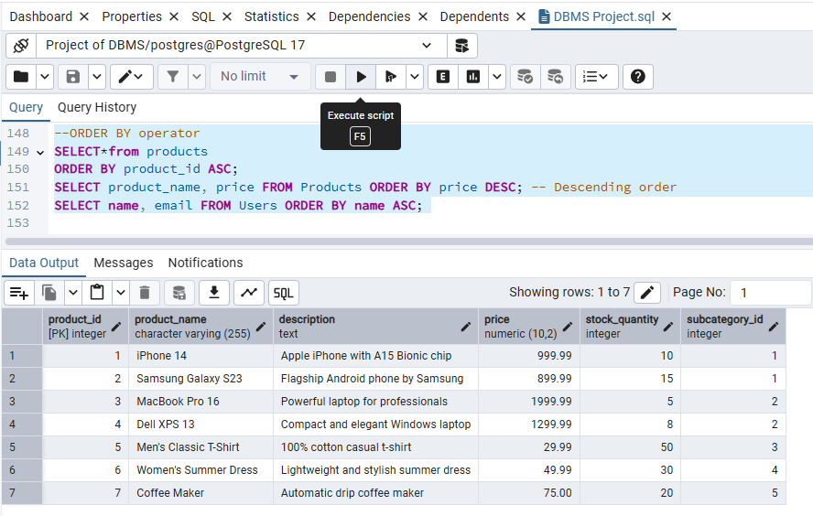

- Using HAVING & GROUP BY clause
This Purpose of this clause is to retrieve such data, who meet with the specific condition declared in HAVING query. This query is used in such cases that retrieve only whose student’s data whose cgpa is greater than 3.0 or only show those departments whose students has maximum cgpa greater than 2.70 etc.

--using HAVING clause
SELECT product_id,product_name, description, price, stock_quantity
FROM products
WHERE product_name='iphone'
GROUP BY
product_id,product_name, description, price, stock_quantity
HAVING product_id>1;

- DELETE Clause
DELETE Data using different conditions. It only delete specific data from a column or row does not delete whole table or column.

DELETE FROM users WHERE user_id=1;

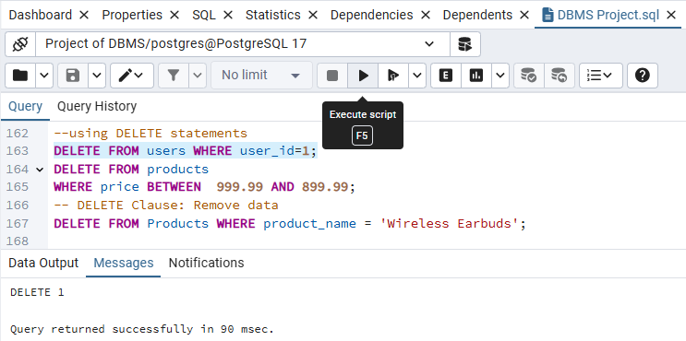

- UPDATE Clause
This clause is used to modify existing data froma database.

-- UPDATE Clause: Modify existing data
UPDATE Products SET stock_quantity = 12 WHERE product_name = 'iPhone 14';

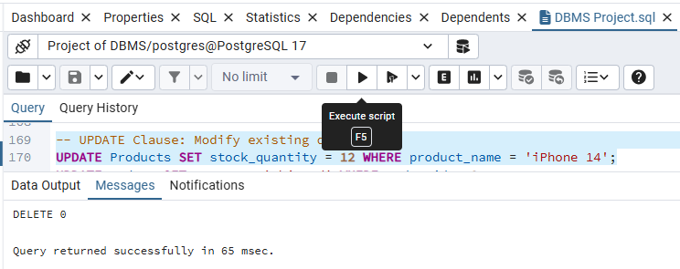

- MIN Clause
This clause used to retrieve minimum number of something such that how many minimum Smartphone is Product list.

SELECT MIN(product_id)FROM products
WHERE
name='iphone 14';

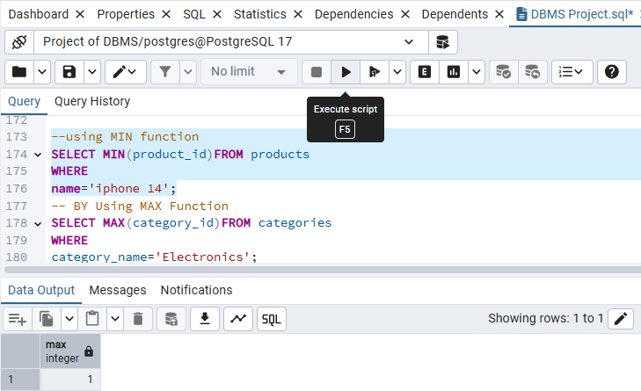

- MAX Clause
Used to retrieve maximum value of something.
-- BY Using MAX Function
SELECT MAX(category_id)FROM categories
WHERE
category_name='Electronics';

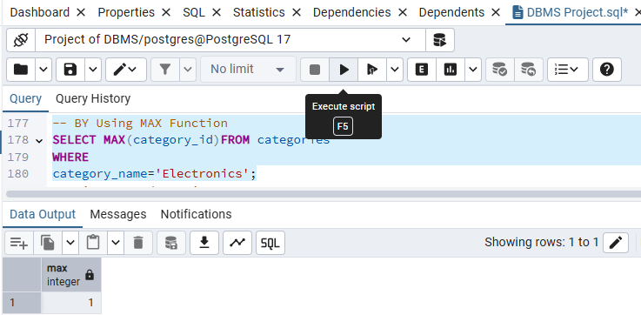
- Nested Queries
Query within query is called nested query.

--Using Nested queries
SELECT *FROM
products
WHERE
price>(SELECt AVG(price)FROM products);

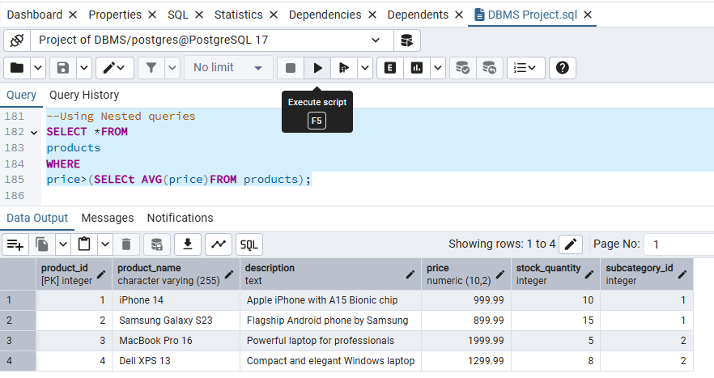

- INNER JOIN

-- INNER JOIN: Products with their SubCategories
SELECT p.product_name, p.price, s.subcategory_name
FROM Products p
INNER JOIN SubCategories s ON p.subcategory_id = s.subcategory_id;

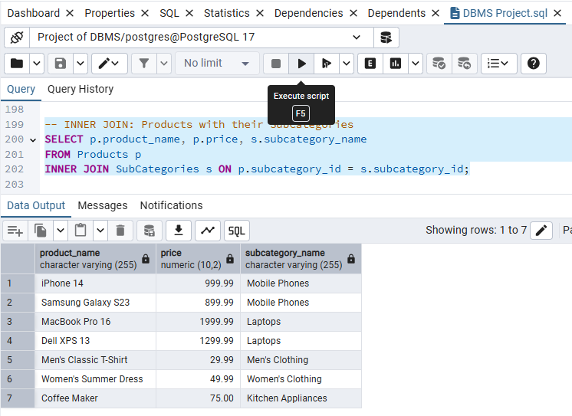

- LEFT JOIN

-- LEFT JOIN: All Categories and their associated SubCategories (even if a category has no subcategories)
SELECT c.category_name, s.subcategory_name
FROM Categories c
LEFT JOIN SubCategories s ON c.category_id = s. category_id;

